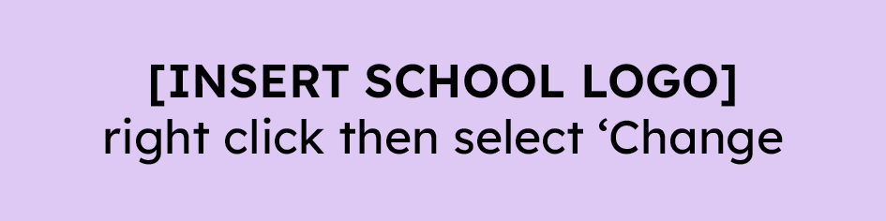

**[INSERT SCHOOL]** Digital device sign-out for home learning

**Device type:** **Serial number:** **Charger:** **Student name(s):**

* I have signed out this device for my child’s home learning. I understand it should be used to connect with their teachers, students, and to engage with the learning as set by the teacher(s).
* I will ensure that my child is appropriately supervised and accessing this device in a safe way (away from liquids or food) and in a setting that best meets their learning needs.
* If this is in a private location or a bedroom, I will regularly monitor and check in with my child as appropriate and realistic based on my whānau’s living situation. I understand that I am responsible for the online activities and interactions of my child on this school-owned device.
* I also agree to cover the cost of any damage to or loss of this device while in use in our home.
* I will return this device to the school within five days of the school requesting return. I will contact my child’s teacher should I have any questions or concerns related to this device and its use.

Signed: Date: